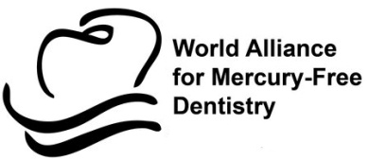

Sustainable Environment Development Initiative

Stakeholders Media briefing on

Phasing Down Dental Amalgam Use in Edo State, Nigeria

Media briefing proceedings

July 14, 2018
Introduction

Nigeria has ratified the Minamata Convention on Mercury and the government has made a commitment to protect human health from anthropogenic emissions and releases of mercury and mercury compounds, including mercury in dental amalgam.
The objective of the event was to mark the civil society consensus to end amalgam use for children, pregnant and breastfeeding women in Edo State by July 1, 2018.
The Sustainable Environment Development Initiative (SEDI Nigeria) organized the media briefing with funds from the World Alliance for Mercury-Free Dentistry (WAMFD).

1.0 Opening Session

A total number of 32 participants attended the Media Event held on July, 14 2017 at the WHARC Event Center, Benin City, Edo State. In attendance were representatives from Government, Dental practitioners, Media and civil society groups. The media briefing was declared open by the Hon. Commissioner of Health – Dr. David Osifo, ably represented by Mrs. Chidi Enunwaonye.
Other dignitaries present were The Hon. Commissioner for Environment ably represented by Mr. Ehon Godfrey, Dr. Franklin Abhulimen (Secretary, Nigerian Dental Association, Edo State), Dr. Leslie Adogame (Executive Director, SRADev), Barr. Charlie Brown, President, World Alliance for Mercury-Free Dentistry, Non Governmental Organizations and a host of Media practitioners representing a broad section of local, regional and national organizations.

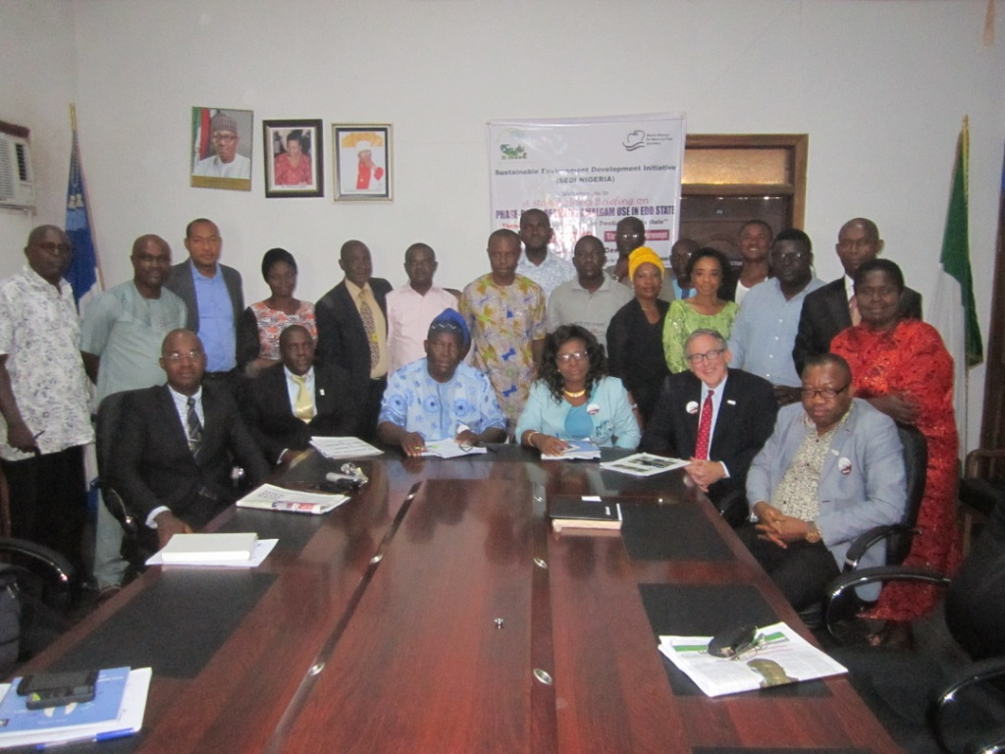
Participants at the Event

1.1 Welcome Address

The Executive Director of SEDI, Dr. Tom Aneni, stated that the stakeholders briefing on phasing down Dental Amalgam Use in Edo State was a follow up to the “Edo State Stakeholder Forum on Phasing down Dental Amalgam Use” which was held on 31 October, 2017. The objective of this event was to mark the civil society consensus to end amalgam use for children, pregnant and breast feeding women in Edo State by July 1, 2018.
He spoke extensively about the impact of amalgam on the development of the children and women’s health. He concluded by stating what a phase down in dental amalgam means for Nigeria which includes: improved dental health and a cleaner environment for children, women and men; and promoting disease prevention, health promotion and protection. He further said that transformative steps have to be taken to move Nigeria on to a sustainable path and ultimately ensuring an amalgam free Africa.

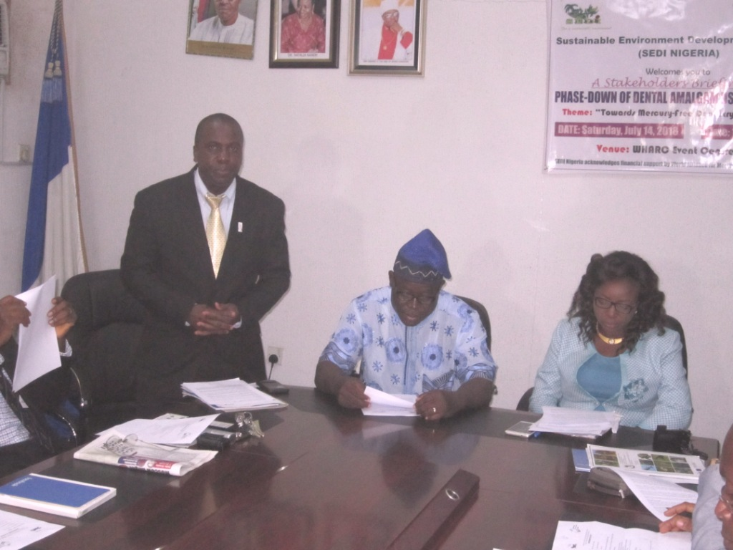
Opening Remarks by Dr. Tom Aneni

1.2 Opening Remark – Hon Commission, Edo State Ministry of Health, ably represented by Mrs. Chidi Enuwaonye

The Commissioner noted the availability of alternatives for amalgam like composite and glass ionomers and the negative effect of amalgam on vital human organs like the heart and kidney. The commissioner observed that amalgam is dangerous to human health and the alternatives enhance tooth colour and use of less filling. She further observed that a good alternative should be accessible, available and sustainable. In conclusion, she stated that ‘if the issue is brought to the awareness of the state Governor, He would support the ban of the use of amalgam in Edo State’. She added that the Ministry of Health supports the use of alternatives for dental filling and would support all measures needed to ensure phase out of amalgam.

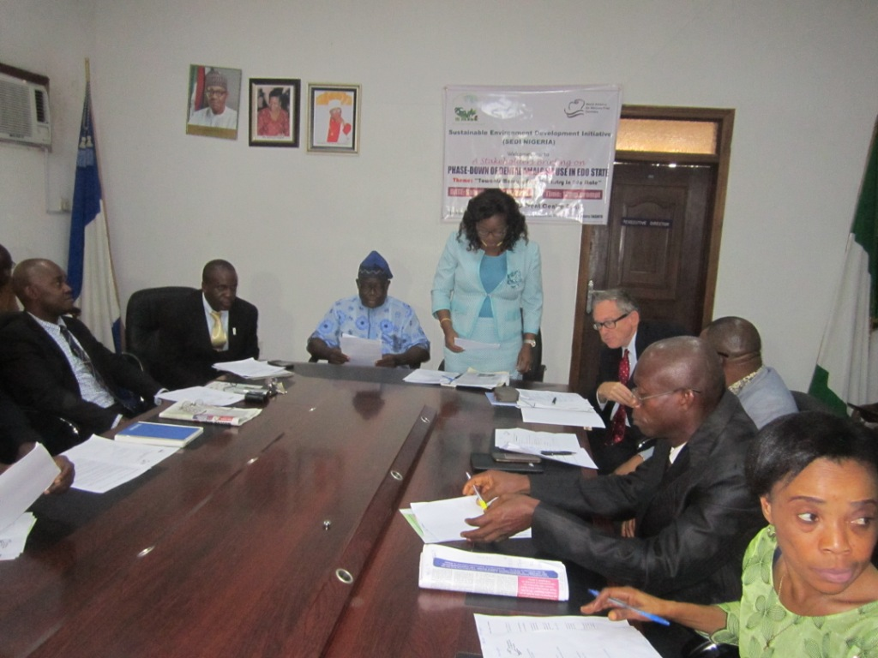
Remarks by Mrs. Chidi Enunwaonye, Rep. of Health Commissioner

1.3 Goodwill messages

1.3.1 Edo State Commissioner of Environment – Ably represented by Mr. Godfrey Ehon (Director for Environment)

He observed that the amalgam phase down campaign is timely. He further stated that there is need for more sensitization and advocacy visits.

1.3.2 Paediatric Unit, University of Benin Teaching Hospital Dental Clinic

Dr. Philip Ogordi, thanked the organizers of the event and stated that there is need for a follow up action towards what has been initiated. He further stated that the Paediatrics Unit does not use amalgam for children. He then put followed a few suggestions which includes:
i. Teaching amalgam as history and not clinical use in dental colleges and schools.
ii. More advocacy workshops.
iii. The amalgam supply chain should be tackled.

1.3.3 Nigeria Dental Association (NDA), Edo State Branch

Dr. Franklin Abhulimen, Branch secretary assured participants of the full support of the NDA, Edo State branch, towards the phase out not a phase down of dental amalgam. He spoke of some few difficulties which include low availability of knowledge and bias from some top personnel. He also stressed the need for the alternative to be more available and affordable. He thanked the organizers of the program. He stated that amalgam is an aspect of the total mercury phase out process, because there are other materials which have mercury. He acknowledged the passion of Barr. Charlie Brown, President WAMFD.
He noted that on February 1st 2018, the President of Nigeria signed the ratification and the focus should focus on the implementation of the process where Edo and Lagos are the pilot. He advocated the need for collaboration between the Health and Environment ministries.

1.3.4 World Alliance for Mercury Free Dentistry

The President, Charlie Brown observed that there was a need to celebrate the campaign effort since 2017. He thanked all actors present for their resilience and effort towards this process. He stated that this campaign should go across other states in which Edo and Lagos States should then be prototypes for other States.
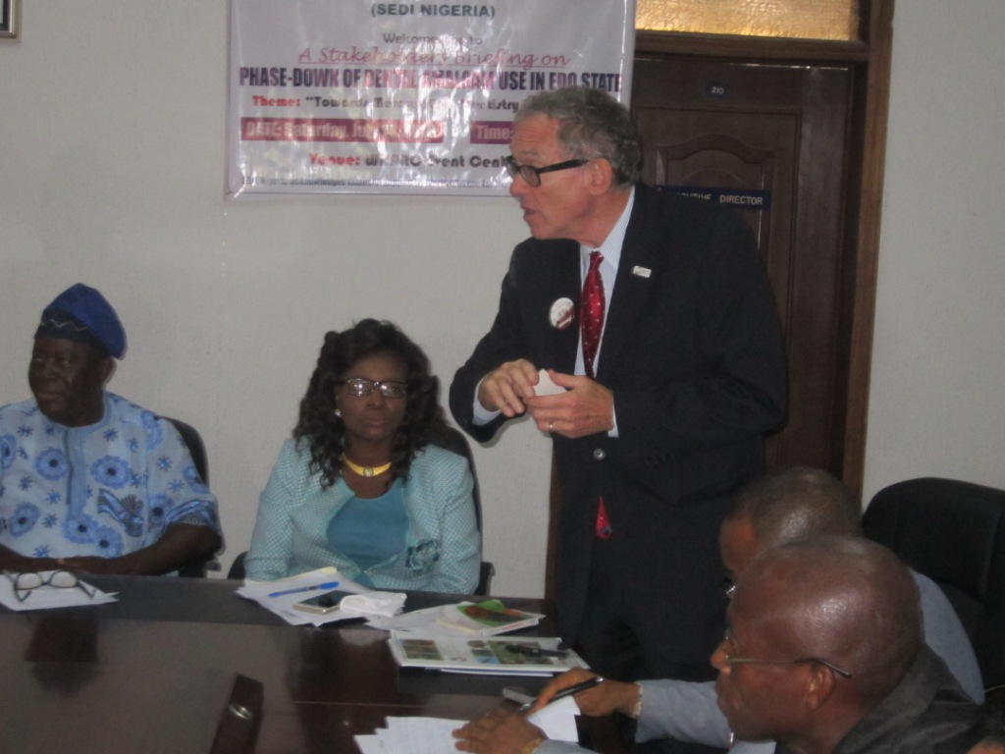
Remarks by Charlie Brown

2.0 Discussion/Questions

Dr. Tom Aneni brought forward the challenge he had during the process of implementation since the last stakeholders’ workshop, which was an absence of a national policy for which the process has started. He also noted the frequent change in desk officers in the ministries. He was advised to work with different layers of career staff.

Osayamen Cyril Okungbowa – ACEPED

He noted the following:
- There should be adjustment in policy framework.
- There is still low awareness on amalgam phase down.
- He spoke on the need for the Federal Government to subsidize the process to make the alternatives affordable.
- There should be change in the curricula of dental schools.

Gabriel Onogholese – Vanguard
What effort is being made to domesticate the process?

Charlie Brown’s Response
The government of Nigeria has shown seriousness by ratification of the Minamata convention. He further noted that there is a need for civil society to drive the process as it is being done in Edo and Lagos States.

Ighomhaye Lucky – Sun Newspaper
What took us so long to know that amalgam is harmful?

Charlie Brown’s Response
He stated that there had first been a conspiracy in the process being that; firstly, the American Dental Association initially called this substance Silver filling which was a total deception to make people not to know about the mercury in it as well as the French Dental Association calling it Lead filling. He further stated that research has shown that the substance contains about 50% mercury.

Uwaifoh Williams – ACEPED
He stated that the media has a role to play in stigmatizing the use of amalgam.

Dr. Franklin Abhulimen – Secretary, NDA Edo State
He appreciated the effort of the media in the whole process. He however pleaded for a proper dissemination of information to avoid misinterpretation from the general population.

Dr. Leslies Adogame’s Reponse
He noted that there are already measures on ground to guide the issue Dr. Franklin Abhulimen raised. He further stressed the need for negotiation and reconciliation in the whole process.

3.0 Vote of thanks and Closing
Dr. Leslie Adogame thanked all participants present and sued for cooperation in the task of ensuring phase down of amalgam in Edo State. He pleaded with the Ministry of Health for a policy statement which is what is required now. He thanked the media for their effort, and their good turnout.

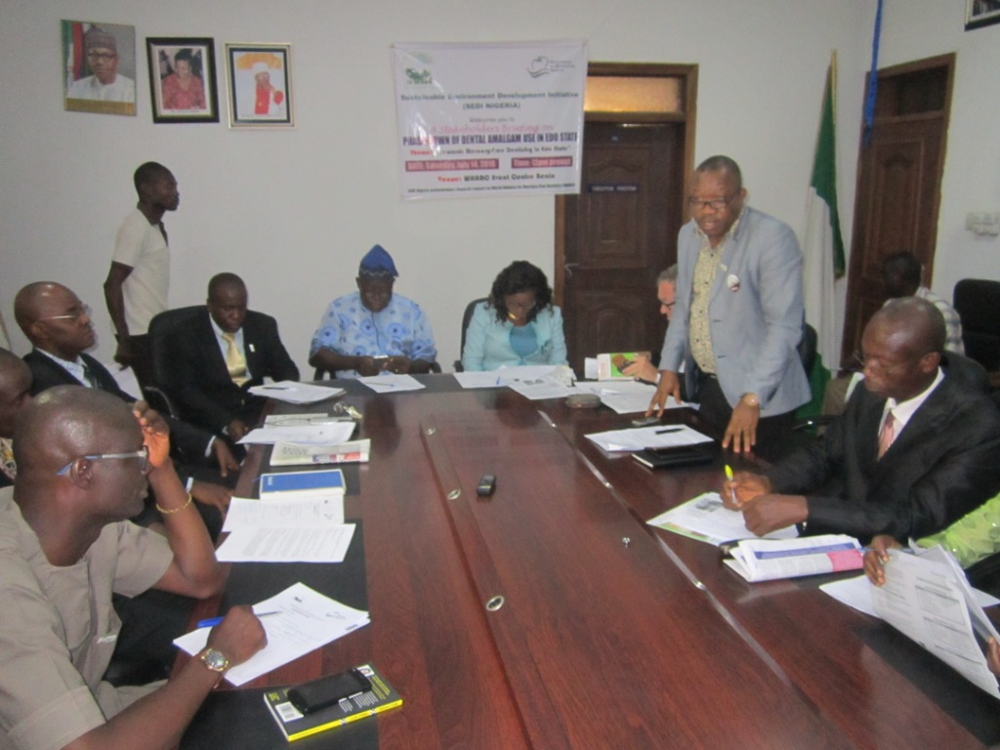
Vote of thanks by Dr. Leslie Adogame

Annex I

Press Statements

https://www.ecogreennews.com/edo-restates-commitment-to-end-use-of-amalgam-for-children/

https://independent.ng/csg-to-mount-capaign-against-amalgam/amp/

https://www.thisdaylive.com/index.php/2018/07/19/stakeholders-call-for-end-to-dental-amalgam/amp/

https://www.dailydispatchnewspaper.com/stakeholders-condemn-use-of-dental-amalgam-say-its-dangerous-to-health/

https://sunnewsonline.com/stakeholders-seek-urgent-end-to-dental-amalgam-use-in-pregnant-womenothers/

https://leadership.ng/2018/07/15/stakeholders-call-for-end-of-dental-amalgam/

https://punchng.com/dental-amalgam-harmful-to-pregnant-women-children/amp/

Annex II

Media Event on Phase-Down of Dental Amalgam Use in Edo State
Theme: *Towards Mercury-Free Dentistry in Nigeria*

PROGRAMME OF EVENT
Media Session: 12.00 - 2.00pm

1. Registration of participants
2. Introduction of the Chairman and high table
3. Welcome Address – Executive Director, SEDI Nigeria
4. Opening Remarks – Hon. Commissioner, Edo State Ministry of Health
5. Goodwill Messages:
a. Edo State Ministry of Environment
b. School of Dentistry, University of Benin
c. Central Hospital, Benin
d. Nigeria Dental association (NDA), Edo State Branch
e. SRADEV Nigeria
g. World Alliance for Mercury Free Dentistry, USA.

Discussion/Questions

6. Vote of thanks/Closing
Photographs
Lunch

“SEDI Nigeria acknowledges financial support by World Alliance for Mercury-Free Dentistry (WAMFD)

Annex III

Welcome Remarks Presented at the Stakeholders’ briefing on Phase down of Dental Amalgam in Edo State – Saturday 14 July, 2018

Protocol
Distinguished Ladies and Gentlemen

Introduction
This Stakeholders’ Briefing on ‘Phasing down Dental Amalgam Use in Edo State’ is a follow up to the “Edo State Stakeholder Forum on Phasing down Dental Amalgam Use” which held on 31 October, 2017.

At the forum, the broad based stakeholders present agreed to the following:
Called for the end of dental amalgam use in children under 16, pregnant and breastfeeding women as of 1st July 2018; and
Urged the Federal government, other States of Nigeria, and all nations of Africa to end amalgam use in children under 16, pregnant and breast feeding women as of 1st July 2018.

Mercury is a chemical of global concern owing to its long range atmospheric transport, its persistence in the environment once anthropogenically introduced and its ability to bioaccuulate in ecosystems. Dental amalgam – a filling for cavities – is about 50% mercury, a neurotoxin and a pollutant that knows no borders.

Nigeria is a signatory to the Minamata Convention on Mercury in Kumamoto, Japan, on 10 October 2013 and on February 1, 2018 deposited its instrument of ratification, becoming the 88th Party to the Minamata Convention, with the government making a commitment to protect human health from anthropogenic emissions and releases of mercury and mercury compounds.

The objective of this event is to mark the civil society consensus to end amalgam use for children, pregnant and breastfeeding women in Edo State by July 1, 2018.

Our Children’s Health
Children, adolescents and youth as important agents of change underline the necessity of investing in them with a view to addressing multidimensional deprivations, harnessing the demographic dividend and empowering them to build a more prosperous future. Health impacts linked to childhood exposure to mercury often do not manifest for years and could include cancer, developmental disorders, and learning disabilities.

Our Women’s Health
Women are the first environment for children and the first educators of children. Throughout their lives, women are exposed to harmful chemicals, including amalgam that can be transferred across the placenta during fetal development and through breast milk to the nursing infant. Amalgam exposures in the womb or in early childhood may cause lifelong harm. Exposures during fetal development increase the risk of such harmful effects as preterm births, birth defects, childhood and adult diseases. Adverse effects can be carried across multiple generations.

Women’s knowledge and understanding of crucial environmental issues is important in building a sustainable future. Women cannot be empowered if they are being poisoned by toxic substances and if their children are born pre-polluted. Gender equality cannot be achieved if exposures to hazardous chemicals leave women suffering from cancer, chronic illnesses, infertility, and damage to their nervous systems. Further, the health of girls and women is critical to reducing child disabilities and mortality, and to improving the health of families and communities. Any threat to women is a threat to our society, economy, security, future and our very survival.

Edo State Advocacy to Stakeholders
- Ministry of Environment
- Ministry of Health
- School of Dentistry
- Nigerian Dental Association (NDA), Edo State Branch
- University of Benin Teaching Hospital
- Central Hospital, Benin
- Edo State Hospitals Management Board (Iguobazuwa, Iruekpen, Uromi, Auchi)
- Irrua Specialist Teaching Hospital
- Private Dental Clinics
- Non Governmental Organizations
- Media

Challenge
No amalgam policy/regulation at the moment, but work is in progress.

What will a Phase down in Dental Amalgam mean for Nigeria
A dental amalgam phase down across Nigeria will amongst others ensure:

1. Ensure improved dental health and a cleaner environment in Nigeria for children, women and men promoting disease prevention, health promotion and protection;
2. Show that it is possible for a broad range of stakeholders to agree on a common goal;
3. Access various opportunities of support available from the Global Environmental facility (GEF);
3. Put Nigeria as a leading nation in the African region; and
4. Ensure a faster adoption of the phase down campaign in the African region in such a way that ‘No one is left behind’.

Conclusion
Transformative steps have to be taken to move Nigeria on to a sustainable path and ultimately ensure an amalgam free Africa.

Dr. Tom Aneni
SEDI Nigeria
National vice-chair, Civil society group on Phase-down of dental amalgam in Nigeria

Annex IV

ATTENDANCE SHEET
S/N | NAME | ORGANIZATION | DESIGNATION | EMAIL ADDRESS | PHONE NUMBER
1 | Bella Akhagba | Bella Foundation for Child & Maternal care | CEO | achildhealth@yahoo.com | 07037314223
2 | Okoukoni Victory | SEDI | Programme officer | okoukonivictory@gmail.com | 08163278438
3 | Abiodun Jimoh | Nigerian Tribune | Media | prompea@gmail.com | 08033375044
4 | Edidiong Sambo | Anti-Corruption & transpiracy support initiative | PM | antiinitiative@gmail.com | 08064618812
5 | Umo Isua-Okoh | Peace Point Action | Director | ppacanopy@yahoo.com | 08055184456
6 | Kayode Aboyeji | Ecogreen news | Editor | kayodeadoye@yahoo.com | 08052470191
7 | Charle Brown | WAMFD | Attorney | charlie@toxicteeth.ng | 1-2025446333
8 | Mrs. Enunwaonye H.Chidi | Ministry of Health | Rep. Hon. Comm. | revalexng@yahoo.com | 08033869339
9 | Dr. Leslie Adogame | SRADEV Nigeria | Ex-Dir | aneadogame@hotmail.com | 08033301305
10 | Princewill Mordi | Ifesnet-Africa | Ex- Dir | Aiesn_african@yahoo.com | 08068354868
11 | Uwaifo Williams Aituae | ACEPED | R.D | Uwaifo.d.ufo@gmail.com | 07036360332
12 | Adibe Emenyonu | This Day Newspaper | Correspondent | adibemenyonu@gmail.com | 08038101422
13 | Dr. Franklin Abhulimen | NDA, Edo State | Secretary, NDA | Frankabhu@yahoo.com | 08068976238
14 | Ighomhaye Lucky | Sun Newspaper | Reporter | Ighoslucky@gmail.com | 08058002402
15 | Alex Okere | The Punch | Reporter | Okerealexander@gmail.com | 07065110552
16 | Gabriel Onogholese | Vanguard | Correspondent | Gabenos@yahoo.com | 08025687543
17 | Usman Bello | Daily Trust | Reporter | abdullaibello@yahoo.com | 07038927513
18 | Dr. Nnawuche Ukachi | Preventive Dentistry, UBTH | Dentist | nnaukachi@gmail.com | 08065184010
19 | Dr. Tom Aneni | SEDI | E.D | tomaneni1@yahoo.com | 08055514010
20 | Abigail Aizebamwan | AFRIWOPED | E.D | Afriwoped@gmail.com | 08054145503
21 | Barr. Agatha Osidee | WOYCAP | E.D | Wocap1@yahoo.com | 07033931313
22 | Dr. Ogordi Philip | UBTH | Dentist | Philip.ogordi@uniben.edu | 08181516035
23 | Hope Eghe Ogbeide | SWAPHEP-Society for Water & Public Health protection |  | swaphep@gmail.com | 08037424999
24 | Maria Obazuwa | GDI | Resource Person | Maysun2003@yahoo.com | 08055215452
25 | Christopher Ogholoh | Cerfads | Benin | Cerfads@gmail.com | 08147298399
26 | Patrick Choga | Leadership | Reporter | NUJ | 08035425690
27 | Ehon Godfrey | Ministry of Environment, Benin | Director | ehongodfrey@gmail.com | 08031392506
28 | Isaac Eranga | Nigerian Observer | Reporter | srhealthadvocate@gmail.com | 08059233001
29 | Frank Onombholo | Daily Independent | Reporter | Oirifrank@gmail.com | 08035940620
30 | Osaigbovo Agbonsalo U. | Living Earth Centre | ED | Agbonsalo.osaigbovo@uniben.edu | 08035452744
31 | Osayamen Cyril Okungbowa | ACEPED | E.D | Okuncyril@yahoo.com | 07037870961
32. | Dr. John Oamen | Central Hospital | Dentist |  | 08159449005

Annex V
Opening Remarks by Rep. of the Honourable Commissioner for Health - Mrs. Chidi Enunwaonye - at the Stakeholders’ Briefing on Phase down of Dental Amalgam in Edo State – Saturday 14 July, 2018.
Protocol
The Hon. Commissioner for Environment ably represented by Mr. Godfrey Ehon, Director of Environment.
All other dignitaries here present.
It is with great pleasure that I am in your midst today to deliberate on the need to gradually phase out dental amalgam with view to replacing it with perceived better alternatives like composite resin. Though Dental amalgam has been in use for over 150 years for filling cavities caused by tooth decay.
Research has shown that amalgam contains 50% of elemental Mercury which is a toxic substance dangerous to heart, kidneys, lungs, cardiovascular system and immune system particularly on the vulnerable group – women, unborn children and infants.
As a result stakeholders have called for the use of alternatives. Studies have been carried out on the alternatives and considerations have been given to:
1. The natural look of the composite fillings which have tooth colour compared to amalgam that cast a grey look on the teeth with time.
2. Adhesion projection: Composite fillings bond with the teeth at the micromechanical level and strengthens it in addition to the cavity filling which amalgam only does.
3. Less drilling with composite filling due to their bonding properties in contrast to amalgam fillings that require more drilling.
In spite of all these advantages there is need for gradual replacement with composite resin or any other alternatives which should be easily assessable, affordable and sustainable.
As we all know our amiable Governor is committed to the health of Edo State citizen and if brought to his awareness will support the ban of use of amalgam.
I as the Commissioner for Health Edo State, support the use of alternatives for dental filling and support all measures needed to ensure gradual phase out of amalgam with use of alternative.
It is a step in the right direction for the Federal Government to have signed and ratified Minamata Convention.
I know we have a lot of discussants here today, so I will give room for discussion and more ideas on this issue.
Thank you and God bless.

