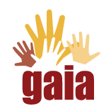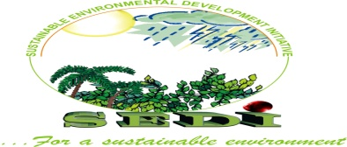

Sustainable Environment Development Initiative

Edo State Stakeholder Workshop

Pathway to Municipal Waste Management in Edo State

Workshop proceedings

September, 2021

Introduction

A primordial and very pressing issue in Nigeria is the problem of municipal waste management. As the nation’s population continues to rise, the accelerating rate of indiscriminate waste disposal from mostly domestic sources makes it of greater concern. Poverty, low standard of living, low level of environmental awareness, urbanization and population growth are some of the key factors that contribute to this puzzling circumstance. Municipal waste management is an important facet of urban infrastructure that ensures the protection of environmental and public health. Several techniques and strategies such as incineration and landfill aimed at tackling the problem of municipal waste disposal have been adopted in times past and have recorded different levels of success, challenges and drawbacks. This prompts the need for communicating innovations and knowledge to achieve desired transformation, overcoming socio-economic and environmental challenges.

This workshop was organized by SEDI with support from Global Alliance for Incinerator Alternatives with the aim of bringing stakeholders together to synthesize the problems and challenges associated with municipal solid waste management and propose conceptual knowledge management approaches and strategies for tackling solid waste problems across the state. Also, to showcase to waste pickers, a good alternative to incineration, landfills and other less environmental friendly methods of waste management and highlight the socio-economic importance of integrating waste pickers in the business of waste management.

1.0 Opening Session
A total of 47 participants (appendix 1) attended the workshop held on the 9th of September, 2021 at the WHARC Event Center, Benin City, Edo State, Nigeria. In attendance were representatives from the Edo State Ministry of Environment, Edo State Waste Management Board, Media, Waste Managers, Academia, NGOs and Waste Pickers from different parts of the state. The workshop was declared opened by the Permanent secretary, Ministry of Environment and Sustainability, represented by Mr. Igho Igbinosa.

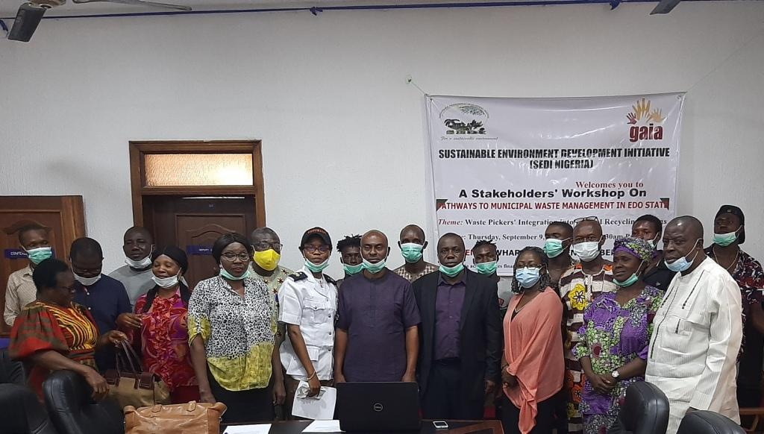Cross Section of Dignitaries during the Workshop
1.1 Welcome Address
The Executive Director, SEDI Nigeria, Dr. Tom Aneni, welcomed all participants warmly and expressed delight in the turn out. He established the relevance of the meeting, which is to unite stake holders to address the complexity and challenges of sustainable waste management as it has become an important concern in all facets of life. He clearly outlined that the workshop is in line with the Federal Government Gazette No. 5, Vol. 98 on the 5R’s of waste management, namely: Reduce, Repair, Re-use, Recycle and Recover. He explained that because most of the constituents of municipal waste, which includes plastics, iron and textile, are not bio-degradable they have to be properly managed to prevent piling up of waste, environmental hazards and ensure that a large portion of these waste are converted to wealth and primary natural resources are judiciously utilized. He stated that waste management is a holistic approach which encompasses sorting, reuse, collection, storage, transport, recovery, recycling, treatment and disposal, most of which involves waste pickers. He described incineration as a method of eliminating waste by combustion. He noted that incineration is a hazardous waste management technique, whose byproducts threaten public health and environmental integrity. In this light, he stated that waste pickers are an important diversion from the norm; incineration, landfills, open-air burning, and a way of reducing poverty, environmental pollution and judiciously maximizing primary resources. He stressed the need for involving all stakeholders in chanting the course of integrating waste pickers in sustainable waste management.

1.2 Opening Remarks
The Permanent secretary (PS), Ministry of Environment and Sustainability, represented by Mr. Igho Igbinosa, expressed his joy and interest in the workshop, spotting its timeliness. He stated that the ministry recognizes the impact of waste pickers and expressed the enthusiasm of the ministry to integrate, train and encourage waste pickers in the waste management value chain. He also stated the interest of the Governor and investors in improving and supporting the activities of waste pickers. Lastly, he implored waste pickers to do away with the old name, “Scavengers” as it is not globally accepted and could be confused for other things. He advised them to adopt and get accustomed to the name “waste pickers”. He thanked every participant for gracing the occasion and specially appreciated waste pickers for their presence.

2.0 Goodwill Messages

2.1 Mr. Mike Igaga - Conference of Non-Governmental Organizations (CONGOs)
He conveyed the delight of CONGOs the organization in the workshop and stressed the need for maintaining a clean environment. He expressed disappointment in the carefree attitude of people towards matters that pertains to environmental preservation and stressed the need for public enlightenment on proper waste disposal across the state. He thanked the Global Alliance for Incinerator Alternatives (GAIA) and SEDI for convening the workshop to address such a pressing issue.

2.2 Mr. Israel Osabuohien - Otofure Dump Site leader
He appreciated GAIA and SEDI for organizing the workshop, and as well thanked all stakeholders present for gracing the meeting. He declared the willingness of the Otofure dumpsite waste pickers to key into the schemes that add value to solid waste management and ensure its actualization.

2.3 Mrs. Efosa Imade - Edo State Waste Management Board
The representative of the General Manager (GM), Edo State Waste Management Board, Mrs. Efosa Imade conveyed the goodwill of the GM at the workshop. She stated the intention of the board to participate actively in the program and cooperate with waste pickers in ensuring that they get the best support as they do their job.

3.0 Presentations

3.1 Mrs. Efosa Imade - Waste Management: Best Practices for Non-Incineration
Alternatives
Mrs. Efosa Imade, Asst. General Manager (Compliance), Edo State Waste Management Board, educated stakeholders on what waste management is and all it entails. She expressed her satisfaction in waste pickers as an important part of waste management and sincerely appreciated all waste pickers. She defined waste management as the processes and actions required to managing waste from its inception which is usually the point of generation at homes, offices, schools and other places to its final disposal at dump sites. She advised everyone to be actively involved in the course of waste management and not leave the job to waste managers alone. She encouraged participants to adopt the practice of sorting out their waste before disposing. She outlined the role of the waste management board which includes: sensitization, advocacy, compliance and monitoring for the purpose of regulating all waste management related activities. She stated the government’s interest in ensuring that the state remains clean, recalling the failed intention of the board to integrate waste pickers in the past. She noted that the business of waste recovery and effective waste management has so much potential to offer and also faced with great challenges like resistance from residents, inadequate funding, lethargy, lack of awareness and obsolete facilities. Furthermore, she described the most effective waste management practice as one that works towards achieving the Reduce, Reuse and Recycle pathway. She stated that the waste management practice in Edo State is guided by a law, which is the Edo State Sanitation and Pollution Management Law no 5 of 2010. She went further to describe accredited waste managers as people who invest their money into the business of waste management and contribute to waste management in the state. She also highlighted government approved dump sites, integrated waste management system, enforcement arms as some other facets that are involved in waste management in Edo State. She educated stakeholders on the positive impact of waste picker’s activities in reducing the quantity of waste disposed, ultimately promoting sustainable waste management. She also gave a rundown on the waste management hierarchy from the most preferred to the least preferred. She stated that waste prevention which is at the top of the hierarchy is the best and most preferred on the hierarchy and waste disposal as the least preferred. She advised waste pickers to always protect themselves as they do the job and encouraged them to always wear protective covering, take precautions as safety is first in all we do. She concluded with an encouraging waste to wealth message to the waste pickers and advised them to do their work with so much dignity as they are very much appreciated.

3.2 Mr. Igho Igbinosa - Understanding Benefits: Organizing and Formalization of Waste
pickers
Mr. Igbinosa stated that human activities must always lead to waste generation. He went ahead and highlighted the activities involved in solid waste management and noted that any defect or compromise in any of these activities will disrupt the efforts geared toward waste management. He stated that little or no attention is being given to proper waste management and treatment in the country. He appreciated the fact that waste pickers are gradually gaining attention as a main avenue through which solid waste are sorted and integrated back into the system for reuse or recycling to reduce waste. He described waste pickers as those who make a living out of collecting waste for recycling and reuse purposes. He also gave an over view of waste recycling which is the final destination of waste pickers. He stated that this process is a very useful alternative to incineration and land filling, highlighting some other added advantages such as income generation, job creation, maintaining public health and sanitation, preventing the spread of communicable diseases, mitigating climate change, preserving the life span and carrying capacity of dumpsites, reducing siltation and blocking of drainages as well as reduce pollution from green-house gases. He noted that integrating waste pickers properly into the waste management scheme would encourage the reuse of materials, create partnership between government and private stakeholders in effective waste management.

3.3 Mr Oloye - Presentation of Draft Edo State Waste Pickers’ Constitution
Mr Oloye, the representative of the Otofure dump site waste pickers, presented a summary of the draft constitution. He stated that to ensure the unity of waste pickers, it is therefore necessary to have a constitution that would guide their activities and bind its members together. The constitution includes the proposed name of the association and address. The draft states that the association is open to membership from all stakeholders that are passionate about effective waste management. It also highlighted that the association would have elected representatives and these representatives would be given the right to establish other branches in accordance with the binding rules of the association. He clearly stated the proposed hierarchy of the executives. He noted that there shall be an annual meeting. Five members of the executives shall form a quorum. The association shall have a common seal, kept in the custody of the secretary of the association, who shall produce same when required. The funding of the association shall include donation, grants, loans, levies and other legitimate sources of funding. A financial account shall be prepared from time to time. Vacancy in the executive committee shall be filled at the next executive meeting. The constitution shall be altered only at the general assembly with an at least 6weeks notice before the general assembly. He stated that this constitution shall become effective on the 3rd of January, 2022. He concluded that the association is still working and they would continue to do so as divided we fall, together we stand.

4.0 Comments and Observation
- Mrs Edith, a plastic recycler was the first to express her observations. She appreciated stake holders for their presence, and the waste pickers as well, and stating their importance at the dump sites and to their company (recycling companies) as a source of raw material. She admonished stake holders to participate actively, collaborate and ensure that waste pickers are fully appreciated and integrated into the system. She expressed satisfaction in the process and stated that their company is open for active collaboration to ensure that these waste are properly recovered and recycled.
- Professor Adekunle thanked GAIA and SEDI for organizing such an important workshop and asked the waste management board what they are doing to promote sorting and recycling of waste. She suggested that there could be an incentive to encourage more people to be involved. Mrs Imade responded that the board lacks enough staff to carry out sensitization. She also stated that the government recently recruited some officers, presently in training to carry out this enlightenment. She said that the board is working on making jingles to help enlighten the public. She concluded by saying that the board is working on a system that would self-generate stipends to power this program.
- Dr. Osaigbovo complained about the unfairness of the tariffs collected for waste evacuation. He also asked if the board monitors the activities of waste managers.
Mrs Imade responded by highlighting that if they base the tariff system on the number of persons in a house, the people may not be able to pay for it, especially the poor. So it just has to be that the rich spend more for the same quality of service compared to the poor, while the board works out a more effective billing system. She advised everyone in this situation to channel their complaints to the board where it would be properly addressed. She assured the stakeholders that the board monitors waste managers and sanction defaulting managers. She also stated that they cannot do enough and implored members of the public to supply the board with relevant information on their customer care lines.
- Mr. Oloye asked the waste management board, what they can do to simplify the work of waste pickers and suggested providing them with shredding machines, safety gears and transport at subsidized rates.
- Mrs Abigail Aizebawman asked if the board has enough staff to motivate the people to the extent that they would yield to a change of orientation and key into the idea of waste sorting, reusing and recycling, especially the poor and uneducated. She also pointed out some loopholes in the tariff system, citing Lagos as an example, where one pays for as much waste they generate. She encouraged the board to review the laws, and re-strategize to promote partnership with other stake holders like NGOs.
- Mrs Imade replied and said the board is working on renewing the tariff system.
- The waste pickers also voiced their appeal to the government to repair the dumpsites as the current state of the dumpsites is bad. Mr. Louise pleaded that the government to ensure that the dumpsites are easily accessible by waste pickers and waste conveying vehicles. They also suggested that the government should encourage them and see to their proposed constitution.
- Mr. LuckyOgbonna, a waste picker, expressed his joy in the actions of the government, SEDI and all partners that organized this workshop. He stated that they are very glad to know that their efforts are recognized and appreciated. He then went ahead to say that the government will do so much for them if they are provided with safety materials that would aid their activities. He pleaded that the government implement all the suggestions raised at the workshop.
- Another waste picker, Mr. Zenbe, suggested that the government repair the roads to dumpsites and stated that a good road would make things easier for waste managers, reduce cost and ensure smooth compliance with all these strategies discussed.
Mr. Ugiagbe, from Dellac Foundation asked the ministry of environment for the procedures involved in registering as a waste manager. Mrs, Imade out-rightly stated the criteria which include owning a vehicle for conveying waste to the dump site, having a registered company, registration with corporate affairs commission. She also gave out the phone number of the board: 08109670791 and 08109670790 and her official phone number: 08055061287. She advised the waste pickers to continue fervently in the course of forming an association as it offers them greater chances in getting help, especially from the government.
- Mrs Echie, an experienced educationist also tried as much as possible to incorporate these issues with the prevailing situations in schools, especially government schools. She stated that lately, the school management has been able to provide waste baskets across all classrooms and monitor the attitude of students and pupils, to fine-tune their mindset and checkmate the irresponsible attitude of indiscriminate disposal of wastes at that tender age. A stake holder also advised her to take these things back to the schools and encourage children to segregate waste as they dump their refuse.
Dr. Tom Aneni, concluded this session by recalling all the issues raised and solutions proposed. He encouraged every participant to take all they have learnt and do as much as they can where ever they find themselves.

5.0 Closing Remarks, Vote of Thanks and Closing Prayers
Dr Tom Aneni, thanked the representatives of the Edo State Ministry of Environment and the Edo State Waste Management Board. He specially appreciated members of the CONGOS, NGOs, academia, media, representatives of the Otofure dumpsite and all waste pickers present. He expressed deep appreciation to every participant for their keen attention and contributions. Mrs Abigail took the closing prayer, bringing the workshop to a conclusion.

Appendix 1: List of Participants
S/N | NAME | ORGANIZATION | EMAIL ADDRESS | PHONE NUMBER
1. | Imoisili Idemudia | SEDI | Idkabasa@yahoo.com | 08134227865
2. | Okoukoni Victory | SEDI | Okoukonivictory@gmail.com | 08163278438
3. | Maria Obazuwa | Girls Power Initiative | Sun2003@yahoo.com | 08055215452
4. | Igho K. Igbinosa | Min. of Environment & Sustainability | Maxiroy78@gmail.com | 07033227914
5. | Loveth Etuknwa | Secretariat | Loveth33@gmail.com | 07033327408
6. | Osayi Queen | SEDI | queenosayi40@gmail.com | 07061171190
7. | Oloye Israel Osabuohien | Scavengers | Nil | 07026377265
8. | Oshim Friday Emmanuel | Scavengers | Nil | 08141926372
9. | Lucky Ogboma | Scavengers | Nil | 09066970486
10. | Noamkwn Sunday | Scavengers | Nil | 09078099279
11. | Iguo Chidera | Scavengers | Nil | 09078427516
12. | Ugbo Oke | Scavengers | Nil | 08163687755
13. | Ugbo Chirechevem | Scavengers | Nil | 08063151143
14, | Ugbo Chinedu | Scavengers | Nil | 08151640189
15. | Ukoro Emmanuel | Scavengers | Nil | 09139239258
16. | Oshi Peter | Scavengers | Nil | 07045730895
17. | Osaro Cuobatia | Scavengers | Nil | 09038435275
18. | Azubulke Daniel | Scavengers | Nil | 07013471822
19. | Aliuna Harrision | Scavengers | Nil | 08045927490
20. | Ucha Monday | Scavengers | Nil | 07039989975
21. | Okohu Godstime | Scavengers | Nil | 08065178432
22. | Sanni Jimoh | Scavengers | Nil | 08138854307
23. | Paul Azubike | Scavengers | Nil | 08130897903
24. | Nanduisi | Scavengers | Nil | 09027444023
25. | Osoho Obumneme Samuel | Scavengers | Nil | 08168404840
26. | Nwafor Chikwado | Scavengers | Nil | 08164117871
27. | Simon Chinagorom | Scavengers | Nil | 07041426010
28. | Igwie | Scavengers | Nil | 08142537462
29. | Chris Ogholoh | Cerfads | cerfads@gmail.com | 08147298399
30. | Eichie Margaret |  | Nil | 08104074107
31. | Gbgeuchi |  | Nil | 09075764541
32. | Iga Chibueze | Sun | Nil | 08138285842
33. | Ighomuaye Lucky | Sun | ighoslucky@gmail.com | 08058002402
34. | Prof. A.T. Adekule | Uniben | atadekunle@gmail.com | 08023444139
35. | Dr. A.U. Osaigbovo | Uniben | Agbonsalo.osaigbovo@uniben.edu | 08035452744
36. | Mike Igaga | CONGOS | akderdrullnhohie@mail.com | 07016570804
37. | Agatha Osieke | WOYCAP | wocapl@yahoo.com | 07033931313
38. | Isaac O. Eranga | Nigerian Observer | isaaceranga@yahoo.com | 08059233001
39. | Kingsley Kefe | FODCOR | kingsleykefe@gmail.com | 08054211080
40. | Asengwuvisa | Ministry of Environment | talkziusnza@yahoo.com | 08022160386
41. | Abigail Aizebamwan | AFRIWOPED | afrwoped@gmail.com | 08054145503
42. | Efosa Imade A.B. | EWMB | bimtrice@gmail.com | 08055061287
43. | Okhakumhe Jude | EWMB |  | 08058172129
44. | EfeoghoaImade Mecca | UNIBEN | olam17849@gmail.com | 09072689125
45. | Ugiagbe O. Robert | BELLA Foundation | our-rb4real@yahoo.com | 07033210017
46. | Iyalomhe Edith | Natural Eco Capital | Edith.tobore@gmail.com | 08037729316
47. | Iyalomhe Bassey | Domi Consult | iyalomhebassey@gmail.com | 08096786391
48. | Thomas Aneni | SEDI | tomaneni1@yahoo.com | 08055514010

